**Build guide for the Black Gladiator**

1. Open the box and lay out all the equipment provided and organise them into groups of: Alan screws, nails, wheels and tracks, etc.
2. Get the screws and the screwdriver and use them to connect the wheels to the main body.
3. Adjust the tracks using an Alan key and put them on the wheels interlinked with them so when the motor spins, the wheels move and so do the tracks.
4. Connect the motors provided to either side of the underside of the chassis diagonally opposite each other.
5. Connect two wires to the motors by soldering and have them go through slits in the main body and connect them to the motherboard which then connects to the Pi.
6. 3D print a plastic filament cover for the motors to protect them from the elements and to make it sleeker and more aerodynamic.
7. 3D print a protecting cover for the Raspberry Pi and the components so they don’t get damaged.
8. Screw on your protective cover so that it is tight and won’t come off.
9. Programme the motors so that they can move at different speeds.
10. Install a battery holder and connect it to the Pi and motors. Look at picture 2, the orange wire coming out of the back connect to the motors.
11. Connect the light sensor to the RaspberryPi with the red wire connected to pin and download the Adafruit CircuitPython BH1750 Library.
12. Then write the code to make the sensor work and put it into a file to be transferred later.
13. Connect the moisture sensor to the RaspberryPi and download the Adafruit Circuit Python seesaw library then write the code to make it work. Then put it in a file to be transferred later.
14. Connect the Servo to the RaspberryPi and code it to make it work, test it by typing in the numbers to move it and find the maximum distance it can move. Then put it in a file to be transferred later.
15. Transfer the files for all the components using a USB on to a new Pi so they are all on a single, up to date, Pi.
16. Put all the functions into a single file that you can run at one time then program code to incorporate the functions to cycle with the vehicle moving.
17. Insert the Pi onto the main body, underneath the 3D printed cover with all the components in the assigned places. Look at picture 1
18. Check that the Pi works and that all the components work as well.
19. Install the batteries into the battery pack so everything has power and can run
20. Give it a test drive, if it works it is ready to be used. Look at picture 3
21. Enjoy your Farming Robot use it around your farm or customise it for your own purposes.

Picture 1

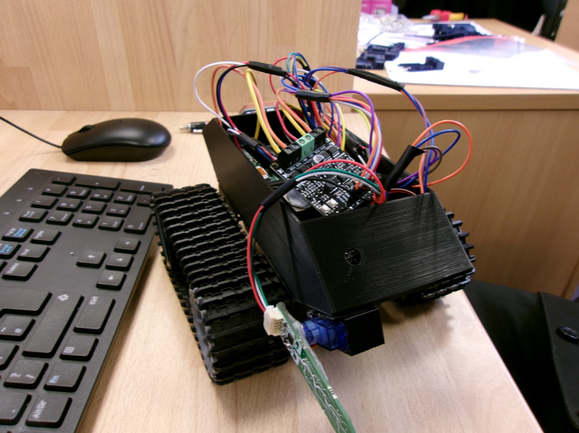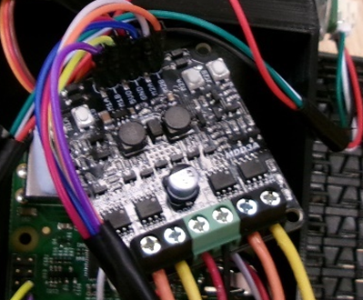Picture 2

Picture 3 